**DAILY ONLINE ACTIVITIES SUMMARY**

|  |  |  |  |  |  |  |  |
| --- | --- | --- | --- | --- | --- | --- | --- |
| **Date:** | **20 June 2020** | | | | **Name:** | **KHATHEEJA SAFREENA.** | |
| **Sem & Sec** | **4th sem, 2nd year** | | | | **USN:** | **4al18cs037** | |
| **Online Test Summary** | | | | | | | |
| **Subject** | | **Data Communication** | | | | | |
| **Max. Marks** | | **30** | | **Score** | | **-----------** | |
| **Certification Course Summary** | | | | | | | |
| **Course** | **INTRODUCTION TO INFORMATION TECHNOLOGY.** | | | | | | |
| **Certificate Provider** | | | **GreatLearning** | **Duration** | | | **6 hours** |
| **Coding Challenges** | | | | | | | |
| **Problem Statement:2 program** | | | | | | | |
| **Status: Executed** | | | | | | | |
| **Uploaded the report in Github** | | | | **Yes** | | | |
| **If yes Repository name** | | | | [http://shafreenasharief / lockdown-coding](http://shafreenasharief / lockdown-coding" \o "http://shafreenasharief / lockdown-coding)  [http://shafreenasharief / locked-down--certification-course](http://shafreenasharief / locked-down--certification-course" \o "http://shafreenasharief / locked-down--certification-course)  [http://shafreenasharief / Daily\_Report](http://shafreenasharief / Daily_Report" \o "http://shafreenasharief / Daily_Report) | | | |
| **Uploaded the report in slack** | | | | **Yes** | | | |

Certification Course Details: (Attach the snapshot and briefly write the report for the same)

Coding Challenges Details: (Attach the snapshot and briefly write the report for the same)

#### *ONLINE TEST SUMMARY:*

#### Today online test was conducted on DATA COMMUTATION. I was not able to attend the test due to some technical issues.I informed about the same issue with the subject faculty.

**CERTIFICATION COURSE SUMMARY:**

Today I started new course **INTRODUCTION TO INFORMATION SECURITY** through **GREAT LEARNING** the course is secluded for 6hrs. After the completion of course, certificate will be provided. I completed all the module .I attempted quiz ,which gave me a clear veiw about the topics that were thought and discussed.It consists of 7 modules which also include assessments.

#### 

***CODING CHALLENGE :***

Today I solved 2 coding challenge,

1. **Write a C++ Program to rotate an array by K positions.**

Circular array rotation means rotating the elements in the array where one rotation operation moves the last element of the array to the first position and shifts all remaining elements to the right.

For example, consider the following array = [4, 5, 6],  
• Initial array [4, 5, 6]  
• After one rotation [6, 4, 5]  
• After two rotations [5, 6, 4]

OUTPUT

Element at index 0: 5  
Element at index 1: 6  
Element at index 2: 4

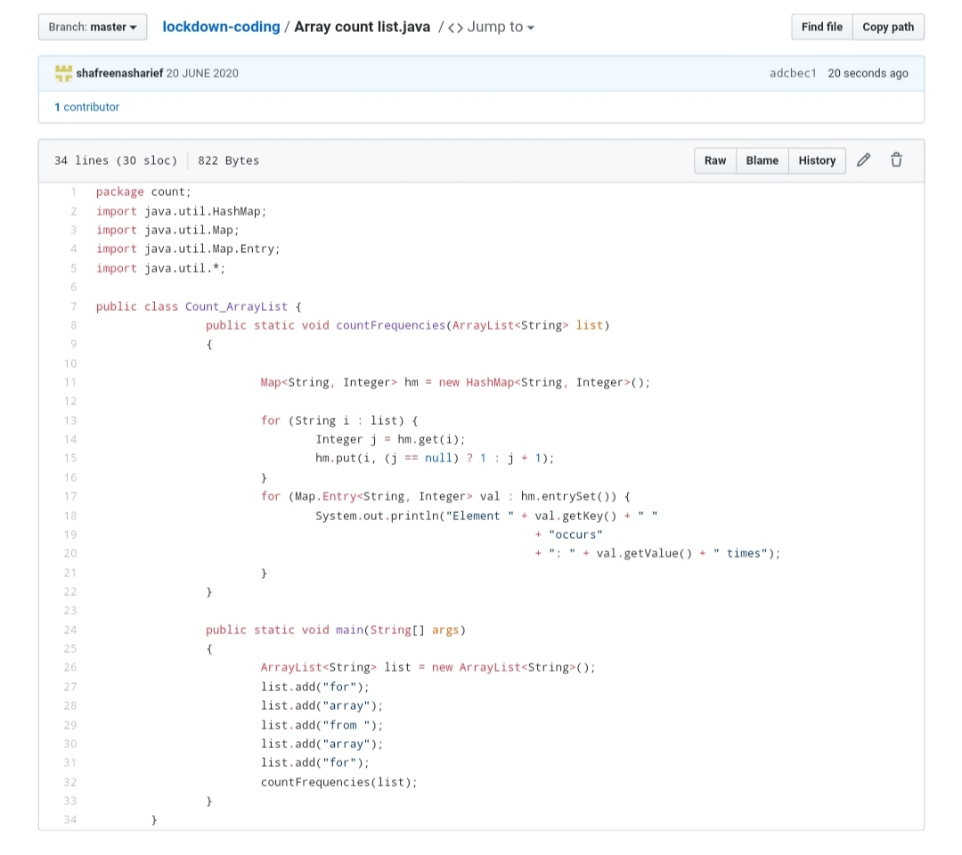

2. **Java** **program that compares counting words in files using an Array List and a Map.**

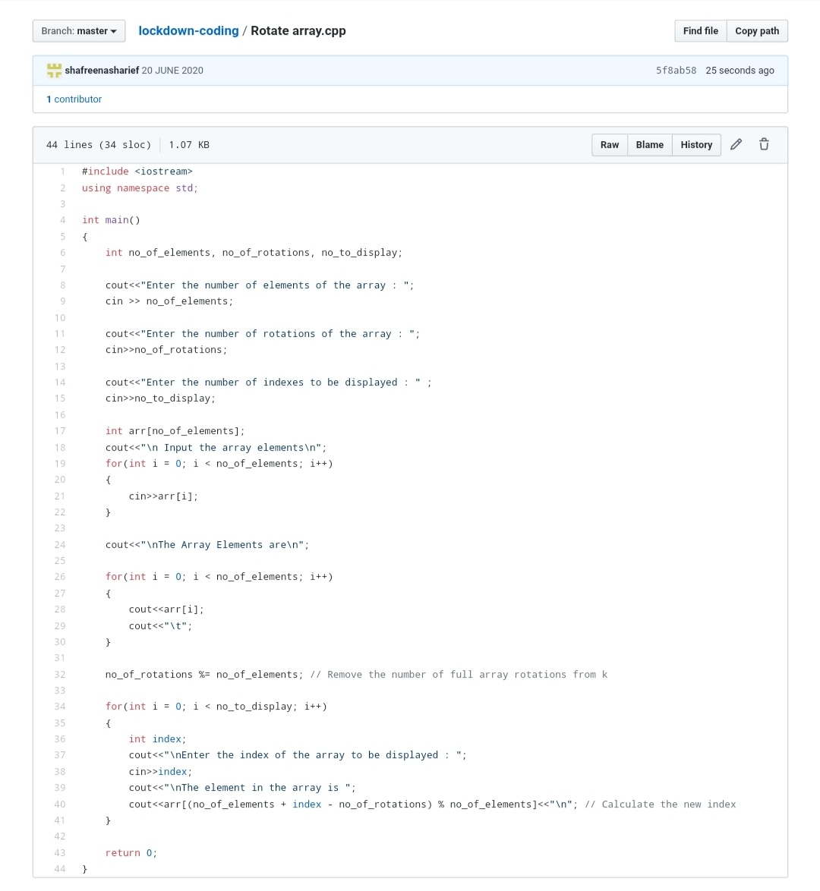

**SOLUTION : I have uploaded the solution of the above 3 coding problems in my GitHub repository.**

**[http://shafreenasharief / lockdown-coding](http://shafreenasharief / lockdown-coding" \o "http://shafreenasharief / lockdown-coding)**

[http://shafreenasharief / locked-down--certification-course](http://shafreenasharief / locked-down--certification-course" \o "http://shafreenasharief / locked-down--certification-course)

[http://shafreenasharief / Daily\_Report](http://shafreenasharief / Daily_Report" \o "http://shafreenasharief / Daily_Report)